
Submission on the Draft NZ Cycling Design Guide (Aug 2003)
Introduction
The Cycling Advocates Network (CAN) is pleased to present this submission on the above document. The national committee of the group has prepared this submission, with feedback from CAN members. CAN has based its submission on reviews of the draft CDG document, Austroads Part 14, and background research material. If you require any clarification of the points raised by us, please feel free to contact us as detailed below.
General Comments
CAN is very glad to see the draft CDG finally out for consultation. Both designers and advocates alike in New Zealand keenly anticipate the resulting final document, which should enable a more consistent and higher standard of cycling design throughout the country.
CAN urges Transit to now publish the revised CDG promptly - before the NZ Cycling Conference in October would be a logical deadline. Although there may still be some contentious issues that will require further field testing and feedback, these can be dealt with as updates in much the same way that the State Highway Geometric Design Manual came out as a provisional document for use.
A number of the suggested items below are based on material in the recently developed "Fundamentals of Planning & Design for Cycling" training course (the people in the development consortium are all CAN members). We understand that Transit has a copy of the final course material and suggest that (where possible) the CDG be aligned with the advice developed in the training course.
Although some figures in Austroads Part 14 (A14) have been replaced by New Zealand alternatives in the CDG, there are a number of others that could also be replaced with more appropriate local details. There are also some figures in A14 that do not show good/best practice, and we feel these should be clearly pointed out in the CDG to avoid confusion. Specific figures will be identified in the comments below.
Specific Comments
CAN would like to offer the following feedback on issues referred to in the draft CDG. Where no comments have been made, then tacit agreement with the draft can be assumed.

Foreword
The Foreword needs to make quite clear to readers that references in the CDG to Austroads Part 14 relate to the 1999 (red) 2nd edition, and not the 1993 (pink) 1st edition, which is significantly different in places.

Glossary of Terms
Some further terms to include in this section are "Advanced Stop Lines" and "Advanced Stop Boxes" (section 5.4.2.2 includes some relevant discussion that could be shifted here).

2.4.2.2 Type of Facility Required
CAN supports the proposed criteria for cycle facility selection in Figures 2-4 and 4-1. However, the figures are fairly difficult to interpret and we suggest a more graphical means of getting across the key information. The chart below is our interpretation of options for on-road provision, based on similar motor traffic speed/volume charts found in guidelines like CROW and IHT/CTC. We expect that a simpler flowchart would still be required first, to identify the need for any specific cycling provision.
Suggested Facility Selection Diagram
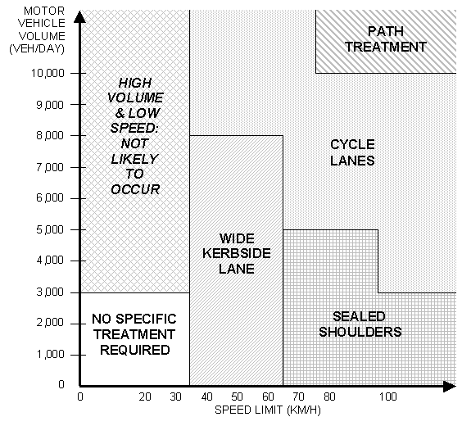
A point that needs to be clearly noted in the accompanying text is that specification of a path treatment does not automatically imply that cyclists should be prohibited from using the roadway. Cyclists fall under many different categories and many experienced cyclists (particularly training and commuter cyclists) will not find a path solution acceptable for their needs (especially if it is inconvenient or indirect in any way relative to the road). Many modern high-speed expressways feature shoulders of a good width, perfectly suitable for cycling on; we note that the recently opened Waikato expressway section features excellent cycle lanes in the shoulders. Cyclist prohibitions should be considered on the technical merits of the road environment, rather than just on assessment of the motor traffic function of the road. The above discussion (or similar wording) needs to be included in the CDG.

3 Bicycle Rider Requirements
In relation to CDG Figure 3-1(b), it needs to be clearly pointed out in the text that interpolation of widths for "in-between" speed limits (e.g. 60 km/h) is acceptable.

4.3.2 Finding Space
While the A14 text is very good, it does omit mention of "road diets"; a very common treatment in North America where a four-lane road is converted into a two-lane road with cycle lanes (and possibly flush median). This option should be mentioned in the CDG.
One thing lacking from the CDG is handy guidance on the minimum road widths required to achieve various traffic lane configurations (there is one paragraph at the bottom of p.14). A14 provides some information like this under 4.4.7 (Wide Kerbside Lanes) although it is overly detailed. A lot of cycle provision work consists of "retro-fitting" cycle facilities onto existing roads. This requires some understanding of what can reasonably be accommodated within various road widths. We suggest inclusion of a table like that below, to enable designers to quickly identify what configurations are practically feasible in their particular situation (it may also be useful to include figures for three-lane carriageways). Alternative table layouts may be worth considering, but the same information should be retained. Note that these are not "desirable minimum" widths; it is not expected that these widths would be used when providing for cyclists on new roads or when kerb replacement is proposed.
Suggested Minimum Road Carriageway Width Table
Minimum Carriageway Width Required for... |  | No Parking |  | Parking One Side |  | Parking Both Sides
 |  | 50 km/h | 70 km/h | 50 km/h | 70 km/h | 50 km/h | 70 km/h
Two-lane carriageway | with wide kerbside lanes | 8.0m | 8.4m | 10.4m | 10.7m | 12.8m | 13.0m
Two-lane carriageway | with cycle lanes | 8.4m | 9.6m | 10.8m | 11.9m | 13.2m | 14.2m
Two-lane carriageway | with flush median and cycle lanes | 10.9m | 12.1m | 13.3m | 14.4m | 15.7m | 16.7m
Four-lane carriageway | with wide kerbside lanes | 14.0m | 14.8m | 16.4m | 17.1m | 18.8m | 19.4m
Four-lane carriageway | with cycle lanes | 14.4m | 16.0m | 16.8m | 18.3m | 19.2m | 20.6m
Four-lane carriageway | with flush median and cycle lanes | 16.9m | 18.5m | 19.3m | 20.8m | 21.7m | 23.1m
Assumptions used for these calculations: (50 km/h) (70 km/h)
- Basic traffic lanes: 3.0m 3.2m
- Wide kerbside lanes: 4.0m 4.2m
- Basic cycle lanes: 1.2m 1.6m
- One side of parking: 2.4m 2.3m (parking lane + buffer space)
- Flush median: 2.5m 2.5m

4.4.1.1 Cycle Lanes - Description and Purpose
On pg.11, first bullet point, a possible exception to providing cycle lanes on both sides might be on a steep grade where downhill cyclists may be able to keep up with other traffic and the narrow cross-section precludes cycle lanes on both sides.

4.4.1.2 Application Details - Cycle Lanes Next to the Kerb or Road Edge
The above title is quite clumsy and we suggest that a simpler term like "Roadside Cycle Lanes" (with a suitable definition in the Glossary) be used instead.
CAN supports the proposed widths prescribed in Table 4-1.
The terms "desirable minimum width" and "acceptable width range" need to be properly explained, so that people understand when to apply them. We have a concern that if their intention is not made clear, many designers will look to use the minimum acceptable width by default in many cases. In practice, desirable minimum widths should be applied to all new road construction (including kerb realignment) and where possible elsewhere, whereas projects retrofitting existing roads may work within the acceptable width range if necessary. To further emphasise the "undesirable" nature of the minimum acceptable widths, we suggest that these ranges be renamed "tolerable width ranges". The situation is further complicated somewhat by Austroads Part 14's use of "absolute minimums" as well; we support the CDG's move to have just two levels of standard.
The maximum widths for cycle lanes need some additional discussion in the CDG. Firstly, in Note 2 to Table 4-1 a more specific figure is needed than “where demand for cycling is so great”. Other guidelines indicate that a typical one-way cycle lane can handle up to 150 cyclists in the peak hour before additional width is necessary. Secondly, for lane widths >2.0m, diagonal painted hatching in the part of the cycle lane nearest to the traffic lane may be useful to indicate a separation area between motor vehicles and cyclists, provided that at least 1.5m of unmarked cycle lane width remains.
Regarding Figure 4-4, a useful visual aid to the diagrams would be to display appropriate speed limit signs on the "berm" of each road cross section (same with Figures 4-7 and 4-19). Also, where the speed environment is 70 km/h, a traffic lane width of 3.2m would be perfectly acceptable.

4.4.1.3 Application Details - Cycle Lanes Next to Parallel Parking
CAN does not support the proposed widths prescribed in Table 4-2. In particular the minimum parking widths of 2.1m do not match what is already being achieved around New Zealand. It should be noted that the 98th percentile motor car width in New Zealand is ~1.8m; therefore a 1.9m parking lane is a perfectly adequate "acceptable minimum", and 2.0m a suitable "desirable minimum". While a wider parking lane might be sensible for traffic efficiency and safety when directly next to a traffic lane, in this instance the cycle lane itself provides the appropriate "buffer space". Any additional width available should be given to the cycle lane, to limit lateral variation (“parking discipline”) of motor vehicles and to allow cyclists to position themselves optimally away from both parked and moving motor vehicles. It is not too critical if the occasional vehicle is not able to fit inside the parking lane (especially heavy vehicles), as the average vehicle lateral position should effectively be further away from cyclists.
We note that, as it is currently worded, Note 3 to the above table is redundant in specifying minimum combined widths; it merely tells us what is already prescribed in the acceptable minimum widths of Table 4-2. The purpose of this note is to make clear that minimum cycle and parking lane widths should not be used together, as this further compromises cyclist safety.
The widths in Figure 4-7 do not match those in Table 4-2, but do seem more appropriate. We therefore suggest the following revised dimensions:
Suggested Cycle Lane and Parking Dimensions (with Parallel Parking)
Road Speed | 50 km/h or less |  | 70 km/h
 | Cycle Lane | Parking | Cycle Lane | Parking
Desirable Minimum Width (m) | 1.8 | 2.0 | 2.1 | 2.0
Tolerable Width Range* (m) | 1.6 – 2.5 | 1.9 – 2.5 | 1.8 – 2.5 | 2.0 – 2.5
* Total minimum combined width for cycle lane and parking at 50 km/h is 3.6 m and at 70 km/h is 3.9 m.
In the last paragraph on page 14, reference should be made to the previously suggested minimum road width table in Section 4.3.2.
Although not crucial to the point in question, we suggest that the large radius corner curves in Figure 4-22 be reduced. There are traffic safety and pedestrian amenity problems with such curves on intersection corners, and designers should not be encouraged to provide them. This comment also applies to Figures 4-9, 5-11, and 5-15.
To avoid any confusion with some figures shown in A14, we suggest that the CDG also explicitly states here (as it does in 9.6.1.2) that safety strips should not be used in conjunction with cycle lanes adjacent to parking. Instead, the additional width should be incorporated into the cycle lane width. This applies to A14 Figures 4-6, 4-9 and 4-10.

4.4.1.4 Application Details - Cycle Lanes Next to Angle Parking
CAN strongly supports the use of wider recommended clear spaces between cycle lanes and angle parking in the CDG, compared with those specified in A14.
Mention needs to be made about "reverse-in" angle parking, which resolves many of the safety concerns that cyclists have with "front-in" angle parking. We find it strange that some roading practitioners have considerable reservations about reverse-in parking, when most existing parallel parking operates in exactly the same manner. A14's section on angle parking orientation (end of 4.4.2.2) provides a measured discussion on the pros and cons of these approaches and should be repeated in the CDG.

4.4.4 Sealed Shoulders
The discussion on adequate shoulders at passing lanes should be made even clearer, given that MOTSAM specifically states that “sealed shoulder widths on a passing lane should be the same as the standard link sealed shoulder width for that section of road”. Therefore it is not at all appropriate to narrow existing shoulders to provide for a passing lane.
Currently there is no specific guidance in A14 or the CDG on what level of cycle usage justifies wider shoulder provision. CAN recommends that some quantitative information be provided to help determine the appropriate standard. As a starting point, we suggest a chart similar to Figure 5:1 in the old NRB/UTC guide (reproduced below for your information). Although we are unsure of the technical basis for this chart, it could serve as an interim guideline, until some local investigation has been done in this area.
Suggested Guidance on Provision of Rural Cycle Facilities
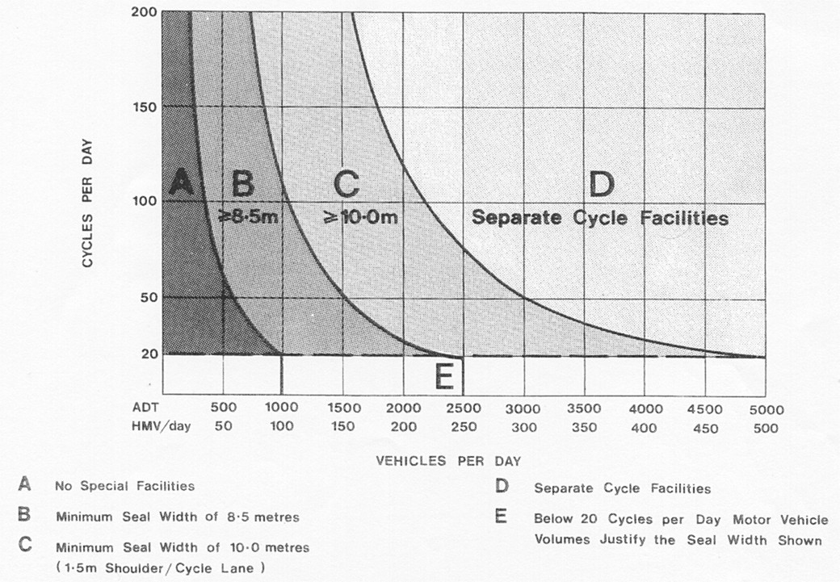

4.4.7 Wide Kerbside Lanes
With regard to Table 4-4, it should be explicitly pointed out in the CDG that, where the available lane width is greater than the maximum values stated, there is usually sufficient width to provide separate cycle and traffic lanes (see discussion in 4.3.2).
Some clarification is also needed of wide kerbside lanes with parking allowed; A14 is not very clear on this issue. Essentially the CDG should only allow parking next to wide kerbside lanes when there is at least a further 2.2m width in addition to the values given in Table 4-4 (i.e. allowing for a car width and additional buffer space in the traffic lane). To avoid confusion (e.g. used as two traffic lanes), the parking lane should preferably be delineated by an edgeline.
A14 provides a number of tables (4-5 to 4-7) containing detailed configuration options for lane widths providing wide kerbside lanes. We recommend that these are not used by CDG readers, as they do not always provide appropriate advice (for example, with 4-lane roads >14.4m in width, there is adequate room to retrofit separate cycle lanes). Instead we would refer readers to the earlier table of minimum road widths proposed in 4.3.2.

4.4.8 Bus/Bicycle Lanes
(This section was partly obscured by Figure 4-19 in the original draft CDG)
CAN endorses the use of sufficiently wide bus/bike lanes where possible. However it may also be appropriate to discuss the option of providing a narrow (i.e. <3.2m) shared lane instead, where space is constrained, so long as adequate operational and safety issues are addressed (e.g. by using occasional passing bays). The CDG should also clearly highlight that “in-between” widths (i.e. between 3.2-4.2m) should not be used because of the ambiguity they pose for buses passing cyclists.

4.5.1 Curves & Turns
With regard to treatment options for inside curves, the CDG should also make reference to Transit’s guidelines in MOTSAM on “profiled line markings” (e.g. ‘Vibraline’), which may be appropriate in certain circumstances.

4.6 Provision for Cyclists on Freeways
This section would appear to require some comment from a New Zealand perspective; otherwise local designers may ignore it, under the impression that "cyclists are not allowed there". Many Australian states allow cyclists to use the shoulders of freeways (equivalent to our motorways), and we see no reason why cyclists here shouldn't be given the same rights where appropriate facilities exist. Section 83 of the Transit New Zealand Act 1989 allows cyclists to use a motorway "where such operation is approved" but, to date, no such approvals have been provided. A number of "expressways" exist in New Zealand however that do allow cyclist access (e.g. Waikato Expressway), and this section provides appropriate guidance on what facilities to provide there.

5.4 Signalised Intersections
CAN does not endorse the final paragraph in A14 before 5.4.1, which recommends that “young and less experienced” cyclists dismount and use pedestrian facilities. A design guide such as A14 should offer reasonable solutions to meet their needs. We suggest that the CDG note that this paragraph in A14 is not appropriate and include possible solutions, such as adjacent pathways/crossings, hook turns, cyclist-only phases and so on.

5.4.2.2 Separate Cycle Lanes on Approaches
Figure 5-11 has a number of problems with it, including:
- No coloured surfacing on approach cycle lanes
- Solid lines for pedestrian cross area missing
- Stop lines for cycle lanes should be right at the pedestrian crossing lines
- A dimension for setting back the traffic lanes from the pedestrian crossing (e.g. 2.0m) should be provided
- The corner curve should have a much smaller radius
These should be corrected.
The last paragraph on p.25 talks about a left-turn exemption sign; however no specific details of such a sign is given (nothing currently exists in the Manual of Traffic Signs and Markings), and it is not even clear if such signage is actually legal in New Zealand.
It needs to be clearly stated in the CDG that shared left-turn/straight-thru traffic lanes next to cycle lanes should not be wider than ~3.0m where possible. Otherwise, it is often likely that traffic will form two separate left/straight queues by straddling the cycle lane. Providing coloured surfacing to the cycle lane may help limit this behaviour.

5.4.2.3 Advance Stop Boxes
CAN has some concerns about the proposed Figure 5-15(c), as it fails to clearly provide assistance for cyclists crossing to the central cycle lane. Therefore the CDG should at least suggest that caution be applied when considering this option. Figure 5-15(d) is preferred where possible.

5.4.3 Phase Times
CAN supports the use of “head start” advance cycle signals where there are problems identified with cyclists turning right, especially on multi-lane roads. We suggest that additional figures be included in the CDG to illustrate this, such as the example shown below from Palmerston North. Where there are intersection capacity concerns, such phases can be set to be "on-demand", i.e. a cyclist has to press a button to get the special cycle-only phase.

Example of “Head Start” Phasing for Right-turning Cyclists
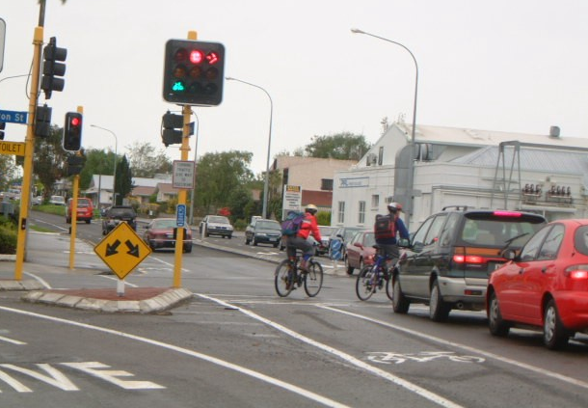 | Text in blue sign says “RIGHT TURN PRESS BUTTON” | 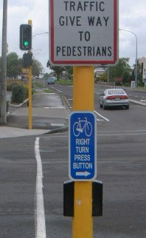

5.5.1 Left Turn Slip Lanes
The treatment in A14 Fig. 5-26 should be strongly discouraged; it violates the principle of giving priority to non-turning traffic (it is interesting that the equivalent Figure 4-18 in the first edition of A14 provided a more appropriate solution). This should be noted in the CDG. Readers should also be directed to RTS 9 - Guidelines for the signing and layout of slip lanes (1993) for further guidance on slip lanes in New Zealand.

5.5.2 Roundabouts
Both the CDG text and that in A14 do not appear to highlight a critical issue regarding roundabout design for cyclists; namely the importance of reducing motor traffic speed. The fact that the only A14 Figures are concerned with details for outer-perimeter paths (a relatively poor level of service for many cyclists) reinforces this perception. Detailed design guidance (including diagrams) on issues such as geometry, deflections, lane widths, and sight distances should be included in the CDG. Some of the European cycle design guides provide useful information in this area.

6 Paths
As with section 2.4.2.2, some discussion is required here in the CDG about not necessarily prohibiting cyclists from the road because of the presence of a cycle path. Where possible, all options should remain available to cyclists.

6.2 Characteristics of Use
It would be worth commenting in the CDG that A14 Fig. 6-1 is quite a poor example of a squeeze point treatment; otherwise we will see more examples like it here. The signs and poles are poorly placed in relation to the cyclist ramp and path, there is limited indication to cyclists to use the path, and the (shared) path appears to be no wider than a normal footpath.

6.3.5 Clearances
Although the CDG raises a valid point about the clearances required for safe cyclist stopping distances, it should also be pointed out in the text that these issues can be somewhat mitigated by various means, including:
- Setting back or splaying obstructions at entranceways/crossings to improve the sight distance at these critical points.
- Slowing down crossing traffic, for example by raising the cycle path relative to the driveway so that it acts as a "hump" for crossing vehicles.
- Temporarily shifting a cycle path closer to the road (or even converting it to a short section of cycle lane).

6.5 Location of Paths for Cycling
A key factor that appears to be missing in the discussion of paths is the practice of locating two-way paths on one side of the road only (the issue is considered in relation to bridges in 7.2.5). Although this arrangement is highly undesirable for cyclists, it is a common option for “economic” reasons (even though one-way paths can be narrower than two-way paths). The resulting path can then provide considerable access and safety problems for cyclists riding the “wrong way”, who have to cross over the road to get to it. We suggest that the CDG discuss this issue and the merits of providing separate pathways on each side of a road. Options for safe crossing treatments to enter/leave the path should also be referred to.

6.7.2 Crossings of Roads
While cycle-path priority crossings as shown in A14 Figures 6-30 and 6-31 are very desirable in many situations, the CDG should point out that the NZ Traffic Rules (existing and proposed) do not allow for this setup. However it would appear possible to provide it via a bylaw, as has been successfully done in Nelson.
With regard to the A14 discussion on signalised crossings, mention should be made in the CDG of the use in Christchurch of advance cycle detectors on pathway approaches to road crossings, so that cyclists receive a green signal by the time they reach the crossing.

6.9 Public Lighting of Paths
A14 fails to mention two important issues that should be raised in the CDG. Firstly, many pathways are located in amongst a lot of trees and other vegetation. Therefore it is very important that the lamps are located to maximise the coverage of the path (i.e. not obscured by vegetation), and that regular vegetation maintenance is carried out.
Secondly, it is important that lighting columns don’t become another potential hazard themselves to cyclists. As with all other structures, they should be located sufficiently far away from pathways (at least 0.5m).

7.2 Road Bridges
Because of the significant cost often of providing adequate cycle facilities to existing structures, some additional discussion in the CDG would be useful to suggest other possible interim options in the short-term. These include:
- Making use of alternative structures, such as abandoned piers/abutments, nearby rail bridges or utility (pipe/cable) bridges, to provide cycle crossings.
- Altering existing footpaths to provide shared facilities
- Providing alternative cycle routes across dry channels or floodplains

7.2.2 Wide Kerbside Lanes
With regard to A14’s suggested width ranges for wide kerbside lanes, it should be recalled from our discussion of 4.3.2 that 8.4m is generally a tolerable minimum width for retrofitting cycle lanes to a 50 km/h bridge (particularly if there is some clear kerb space next to the bridge barriers/railings.

7.2.5 Two-Way Shared Path on One Side of Structure
CAN feels that Figure 7-4 provides a very poor level of service for cyclists, requiring them to loop back considerably to cross to the other side. Many cyclists are likely instead to take their chances crossing the road directly. Some guidance on providing crossing facilities to assist such a manoeuvre (e.g. central refuge island) would be useful in the CDG.

7.4.4 Desirable Widths
The CDG should not endorse the use of 2.0m wide crossing facilities for two-way operation; an absolute minimum of 2.5m should be specified (2.0m for one-way facilities). The presence invariably of vertical barriers or walls next to the facility means that an additional 0.5m must be added onto the 2.0m minimum width for two-way paths.

7.6.2 Fences and Batters
CAN does not support inward-leaning barriers, as shown on the right-side of Figure 7-14 and in Figure 7-17. There is no logic to preventing pedals from catching on the railings, when handlebars are usually just as wide. By contrast, outward-leaning barriers provide some psychological comfort to cyclists, making the facility appear wider than it is. Therefore the CDG should support either vertical or outward-leaning barriers and provide suitable Figures of these.
With regard to Figure 7-13, it is not clear whether the stated requirements for fence barriers next to various drops align with those specified in the NZ Building Act. This should be checked.

9 Traffic Control Devices - Signs and Markings
There doesn’t appear to be any specific details anywhere else about cycle signal aspects; therefore this section of the CDG would appear to be the most appropriate location for it.

9.2 Regulatory Signs
CAN sees little merit in the proposed R1 "Cycle lane" sign, and its optional nature will only serve to confuse the general public. Rather like existing problems with the RG-26 blue cycle disc, people may think that cycle lanes with or without such signs are different in some way (e.g. one is "mandatory" for cyclists). Somewhat more useful guidance in the CDG to practitioners would be that if cycle lanes require more emphasis, the spacing of the cycle logos should be decreased.
Apart from that, CAN supports the introduction of new distinct signage (for both regulatory and guide signs) to replace the existing system.

9.3 Warning Signs
It is not clear in the CDG whether warning signs could also be applied to off-road paths, similar to those found on roads (e.g. steep gradient, intersection ahead, deceptive curve). Allowance for this should be prescribed in the CDG and MOTSAM, preferably using smaller signs than those used on roads.
Sign W1 (cyclist warning diamond) is rather ambiguous on its own. We suggest that various supplementary plates be considered, including a double-ended arrow for a cycle-path road crossing, a “SCHOOL” plate for cycle routes around schools, and a “SHARE THE ROAD” plate where a narrow roadway requires motorists and cyclists to cohabit the same lane (particularly useful for many road-work situations).

9.4 Guide Signs
CAN strongly supports the introduction of a consistent guide signing system for cycle routes. Presumably cycle parking information is also to be catered for in some way (as done by the existing RP-9 Cycle Parking sign) in the CDG and MOTSAM.

9.6 Pavement Markings
CAN supports the proposed new cycle lane marking standard, which provides a considerably stronger message to cyclists and drivers. The new cycle symbol also makes for a simpler, more conspicuous element, assuming that the dimensional requirements are complied with.
The CDG should also explicitly direct readers not to allow gaps in the painted symbols greater than 20mm in width. Many existing stencils are particularly poor in this regard, making the cycle symbols even more difficult to recognise.
Regarding point 8 on pg.43 (symbols facing crossing streets), this advice seems impractical when the height of a properly marked cycle symbol will generally be wider than most cycle lanes. Given the legal significance of cycle symbols, it may be confusing as to which direction the cycle lane is considered to lead to. We suggest rewording this paragraph “Cycle lanes should have frequent marking of cycle symbols, particularly in front of traffic at side streets and high-use driveways, and at other high-conflict areas.”
The recommended spacings in point 9 are too far apart. CAN recommends 100-m spacings on urban roads and 200-m spacings on rural roads (these equate to a symbol about once every 6-7 seconds). It should also be pointed out that these are maximum spacings, and that more frequent symbols should be used where necessary or desirable, such as near intersections or conflict points.
It should be explicitly stated in the CDG that diagonal (hatched) markings fully across the cycle lane are not recommended. As well as adding a potential slipping risk, they cause confusion for motorists and cyclists alike because of their use in other traffic situations too. The exception may be on the traffic-lane side of very wide cycle lanes (still leaving at least 1.5m of unmarked cycle lane width), although other methods such as coloured surfacing and more frequent cycle symbols should considered as well.
There is no discussion in the CDG on the use of smaller-size arrows either on cycle lanes or paths. Some guidance should be provided; CAN suggests that 1/3 or 1/2-scale arrows (compared with normal traffic lane arrows) would be appropriate.

9.7 Pavement Surface Colour
CAN supports a recommendation to have only one standard pavement surface colour. This will resolve any potential jurisdictional clashes between adjacent RCAs (including Transit NZ). Given the geographically widespread adoption of green (with the exception of Christchurch City Council), CAN recommends specifying green for all new cycle lane treatments. However, this should be verified first by review of overseas research into the impacts of different colours on driver/cyclist behaviour and the relative maintenance issues of each colour. Obviously there will need to be a transition period until all existing non-complying surfacing is re-marked. This should not pose any problems in the interim period, as it is the presence of (any) colour rather than a specific colour, that drivers and cyclists are influenced by most.
The discussion in the CDG should provide a more comprehensive list of situations where the use of coloured surfacing may be appropriate (some diagrams would also useful). This should include:
- Approach lanes to intersections (especially between traffic lanes)
- On the departure side of intersections (especially where the lane shifts over laterally)
- Adjacent to areas of high parking use/turnover
- Advance stop boxes
- Across the entry and exit areas of slip lanes
- On the inside of curves
- Across side roads/accesses (particularly where the adjacent traffic lane is regularly queued, blocking visibility)
- Along narrow cycle lane sections (pinch points)
- Contra-flow cycle lanes
- Where it is useful to alert crossing pedestrians to the potential presence of cyclists
- At the transition between cycle paths and cycle lanes
- Shared bus/bike lanes (should always be coloured)

Glen Koorey
Technical & Policy Advisor
for CAN
PO Box 6491; Wellesley St; Auckland
E-mail: secretary@can.org.nz
Website: www.can.org.nz
The Cycling Advocates' Network of NZ (CAN) Inc is this country's national network of cycling advocate groups. It is a voice for all cyclists - recreational, commuter and touring. We work with central government and local authorities, on behalf of cyclists, for a better cycling environment. We have affiliated groups and individual members throughout the country, and links with overseas cycling organisations. In addition, several national/regional/local government authorities, transportation consultancies, and cycle industry businesses are supporting organisations.

Centre for Research & Contract Standardisation in Civil Engineering (CROW), 1993. Sign up for the bike: Design manual for a cycle-friendly infrastructure. Second Edition. Ede, The Netherlands.
Inst. of Highways & Transportation (IHT) and Cyclists' Touring Club (CTC), 1996. Cycle-Friendly Infrastructure Guidelines for Planning and Design. London, UK.
National Roads Board (NRB) and Urban Transport Council (UTC) 1985. Guide to Cycle Facilities, Wellington, NZ.

